# COUNTDOWN TIMER

### A MINI PROJECT REPORT

#### Submitted by

#### Group/Team No: G5/T22

**DEVVRAT DHIMAN**

**2310990408**

**DHRUPAD KAPOOR**

**2310990409**

**DHRUV SHARMA**

**2310990410**

#### in partial fulfillment for the award of the degree of

## BACHELEOR OF ENGINEERING

***in***

COMPUTER SCIENCE & ENGINEERING



**CHITKARA UNIVERSITY**

**CHANDIGARH-PATIALA NATIONAL HIGHWAY**

**RAJPURA (PATIALA) PUNJAB-140401 (INDIA)**

##### DECEMBER 2023

Submitted To :- **Dr. Chetna Kaushal**

Assistant Professor, Chitkara University

# Table Of Contents

|  |  |  |
| --- | --- | --- |
| S. No. | Section | Page no. |
|  | Introduction | 03 |
|  | Problem Statement | 04 |
|  | Technical Details | 05 |
|  | Key Features | 06 |
|  | Project Highlights | 07 |
|  | Code | 08-10 |
|  | Conclusion | 11 |
|  | References | 12 |
|  | | |

**INTRODUCTION**

This is a short project assignment submitted by students of **Group 5**

at CHITKARA UNIVERSITY

**COUNTDOWN TIMER**

This is a teamwork of three students namely:

**1. DEVVRAT DHIMAN (2310990408)**

**2. DHRUPAD KAPOOR (2310990409)**

**3. DHRUV SHARMA (2310990410)**

The **purpose** of this project is to display a clock running for a specific interval of time with the help of **HTML**, **CSS** & **JAVA** **Script**

The **aim** of the project is to learn and understand the basic concepts of **HTML**, **CSS & JAVA Script** in a project way.

**WHAT IS A COUNTDOWN TIMER ?**

Countdown Timer is a device that count downs to a particular event. In this project we are asked to design such a countdown timer using HTML, CSS and JAVA Script and show it’s working as a result on a webpage.

**PROBLEM STATEMENT**

**OBJECTIVE** **OF THE PROJECT :-**

To display a running “COUNTDOWN TIMER” on a webpage using the concepts of **HTML, CSS & JAVA Script.**

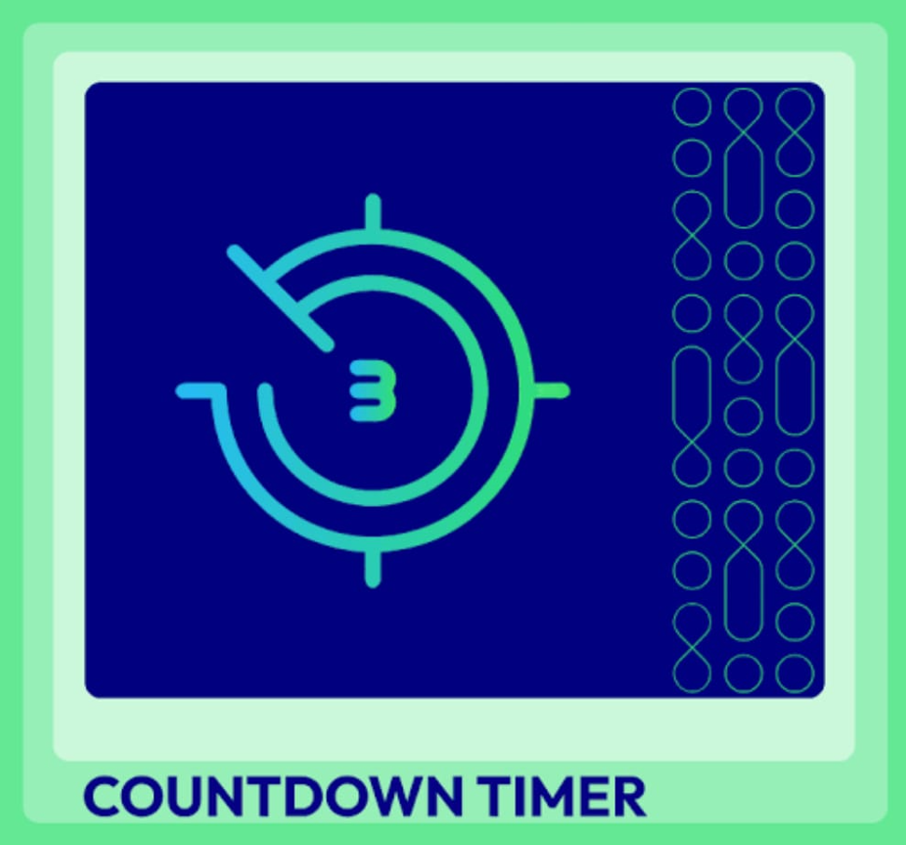

**TECHNICAL DETAILS**

**HTML** : HTML provides a structured way to organize content on the web. It allows us to define the different elements of a webpage, such as headings, paragraphs, lists, images, tables, and more. By using HTML tags, we can create a logical structure for our content, making it easier for both humans and search engines to understand.

**CSS** : CSS (Cascading Style Sheets) is a crucial component of web development that is used for styling and visually enhancing web pages. CSS provides a consistent way to apply styles to multiple elements across a website. By defining styles in a central CSS file, we can easily apply the same visual properties (such as colors, fonts, margins, and padding) to multiple elements.

**JAVA Script** : JavaScript is a widely used programming language in web development that provides interactivity and dynamic functionality to websites.

**CODE EDITOR** : VS Code(Visual Studio Code) is used for text editing in this project. It’s highly interactive and dynamic interface makes user to use it properly and easily. All the code, tags, styling, adding JAVA script is done on it.



**KEY FEATURES**

A few key-features of this project are listed below:

• **Design of a Countdown Timer** : The project focuses on the design and development of exit the plugin pop-up that is commonly used on websites and webpages to show an interactive offer.

• **Use of foundational web development languages** : The project will utilize HTML, CSS and JAVA Script which are the foundational languages for web development.

• **Incorporation of libraries and tools** : The project will use tools and libraries such as a text editor (Visual Studio Code), web browser for testing.

• **Attractive Design** : Create an appealing and visually pleasing design for the Countdown Timer. Use of CSS to enhance the visual presentation of the Countdown Timer and make it visually appearing.

* **About Us** : This page contains the information about our team members.
* **ABOUT PROJECT** : We had attached an external file link that describes our project briefly.



**PROJECT HIGHLIGHTS**

The highlights of the project “COUNTDOWN TIMER” are:

* **Use of Animations**: The project countdown timer makes use of various animations which are being used from Animate.Css.
* **Creativity:** The creativity in the project is the use of fonts, background images,

colors and many more using CSS.

* **Final Results:** The final webpage of this project looks like this

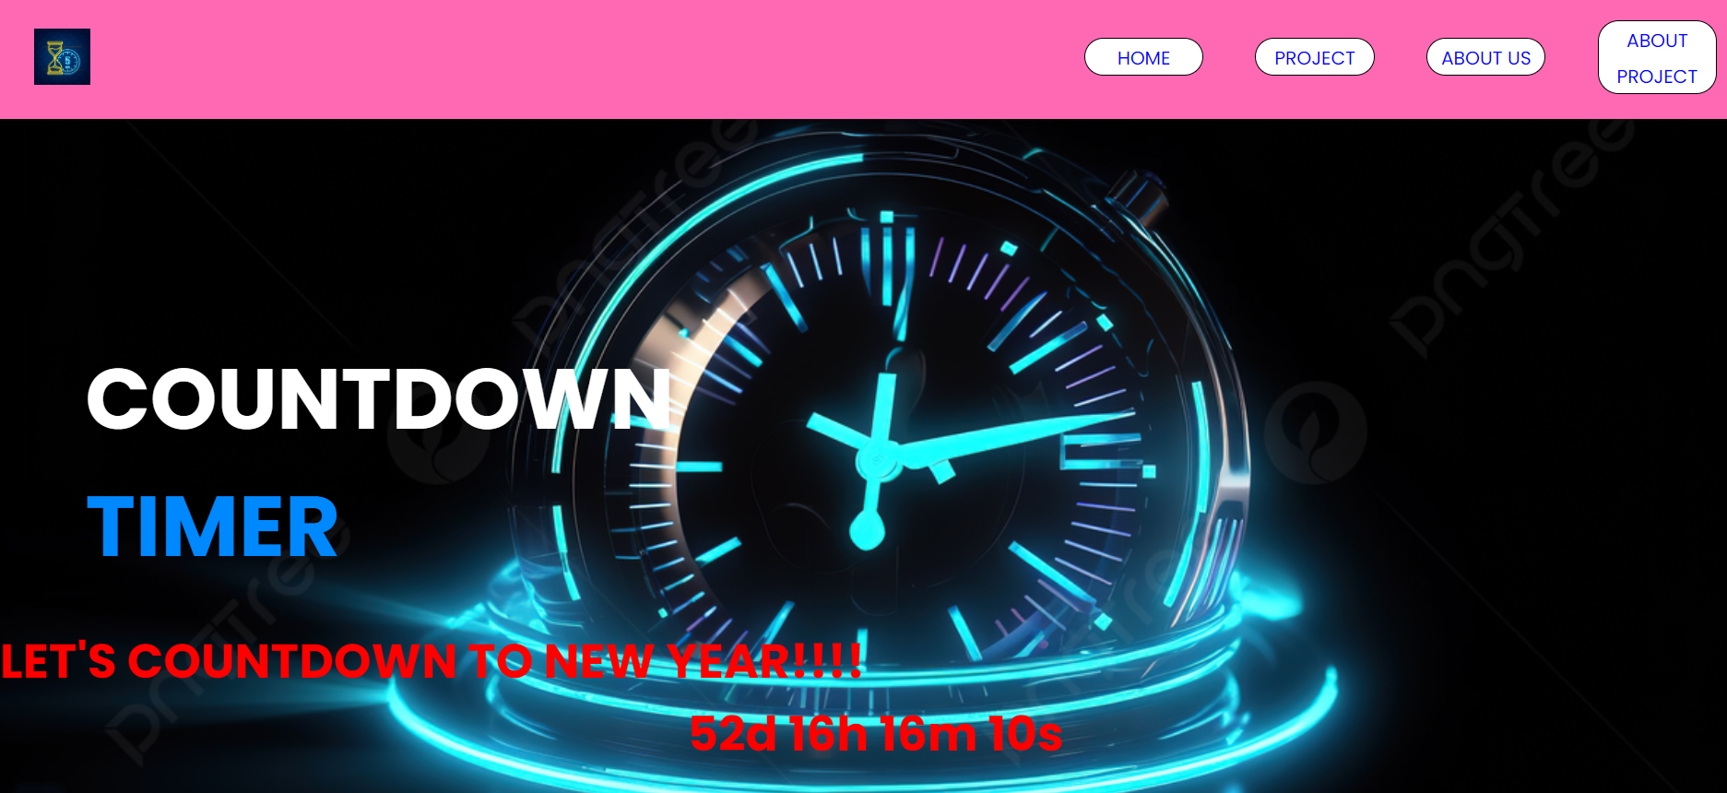



**CODE**

**HTML & JAVA Script**

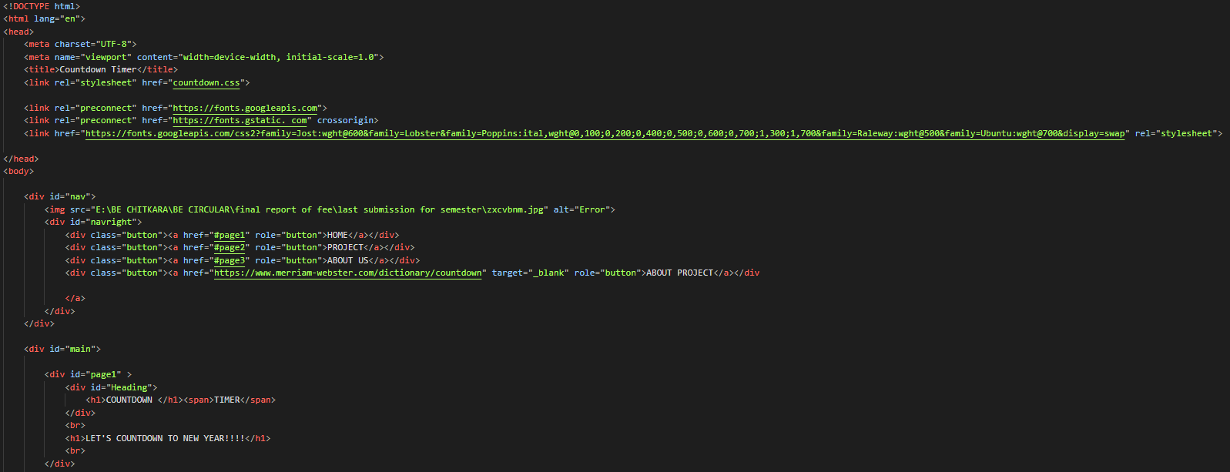

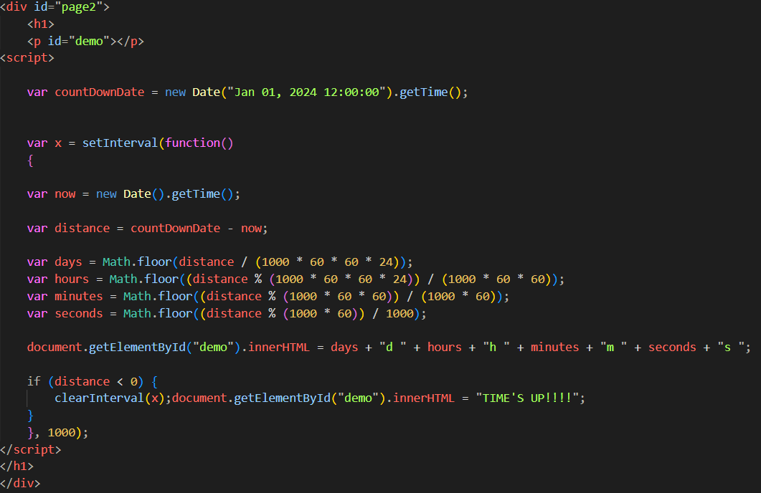

**CSS FILE**

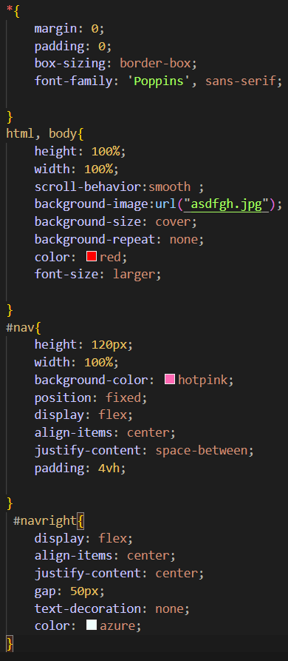 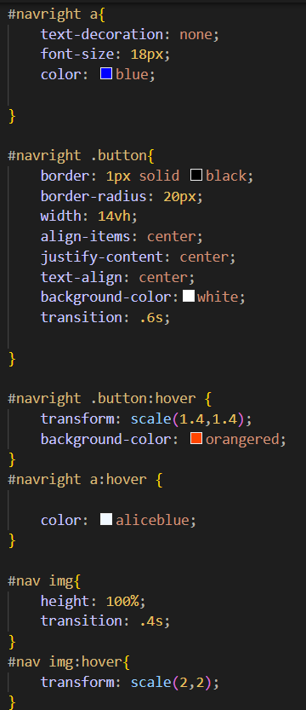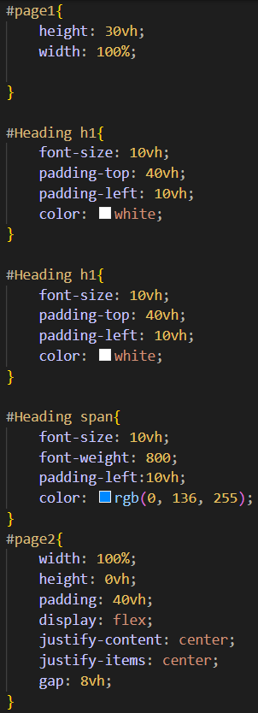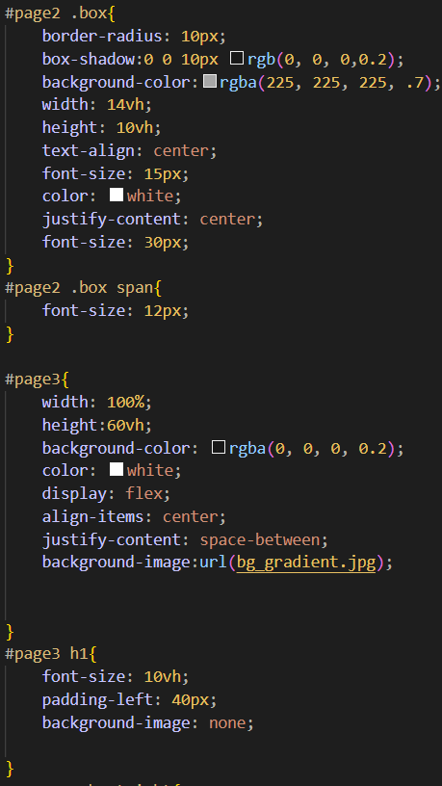

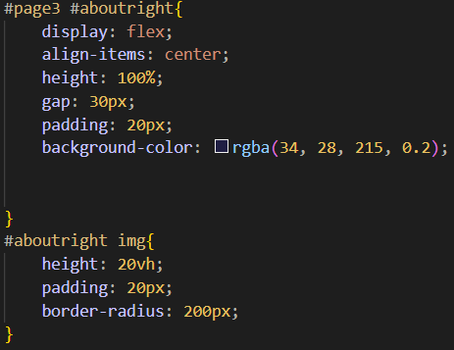

**CONCLUSION**

So, now concluding our Project- “COUNTDOWN TIMER”

I would like to highlight the main take ways from the project and our experience during the project developments.

* The project was quite challenging and interesting as we learn a lot from the project. This project helped us to develop and improve our coding skills in HTML, CSS, JAVA Script more accurately that’s why we are able to develop a webpage to its perfection.
* In the upcoming time there is a wide use of this program as upcoming time is fully dependent on technology.
* Apart from the skills for developing webpage we also learn how to do teamwork and how to cooperate with all the group members.

**REFERENCES**

The project has come to its end with help from external sources.

Some of them are:

* <https://www.geeksforgeeks.org/create-countdown-timer-using-javascript/>
* <https://www.w3schools.com/howto/howto_js_countdown.asp>
* <https://css-tricks.com/how-to-create-an-animated-countdown-timer-with-html-css-and-javascript/>